# File permissions in Linux

## Project description

Here the task is to examine existing permissions on the file system. Then we need to determine if the permissions match the authorization that should be given. If they do not match, we need to modify the permissions to authorize the appropriate users and remove any unauthorized access.

## Check file and directory details

To check the file permissions we use command ls -l or we can use ls -la to even include hidden files permissions:

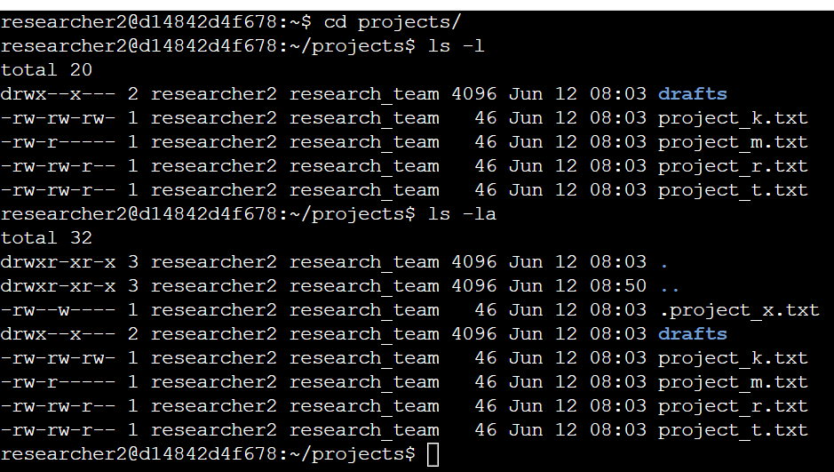

We moved to the projects directory and checked all permissions of the files, hidden files and of the directory.

## 

## 

## Describe the permissions string

Let's understand permissions string with 2 sceanrios >>

1. Let this be our first string -> drwxrwxrwx : so here d means directory(means the permissions in this string are for a directory not a file). The first three alphabets after d are permissions for the user next three are for a group and last three alphabets are for others and here r:read w:write and x:execute.

2. Let's take another example -> -rwx r-- --- : so here first “- “ means its not a directory its a common file first three alphabets after “-” tells that the user have the permissions of read, write and executable where as next three “ r - - “ tells that the group only have permissions of reading and no other permission where the last three “ - - - “ tells that there is no permission to others for read write and not even of execute permission.

## Change file permissions

1. We removed all write permissions of all owner type of other

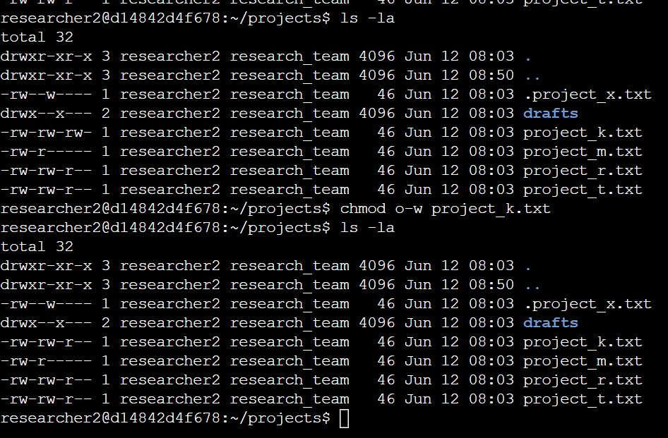

Here only project_k.txt was having permission of write in owner type of other

1. Now we checked for restricted files and found out project_m.txt being a restricted file having read permission in group, so we have to remove it

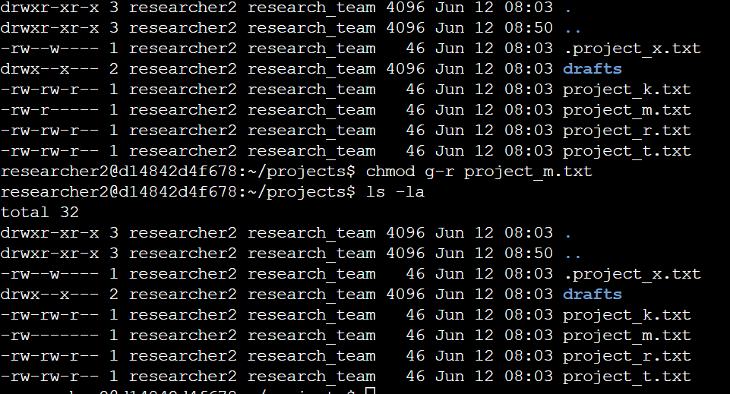

To change the permissions we used: chmod g-r project_m.txt

## Change file permissions on a hidden file

We found from command ls -la that “ .project_x.txt” is a hidden file so we removed the permission of write and left with only read permissions for both user and group

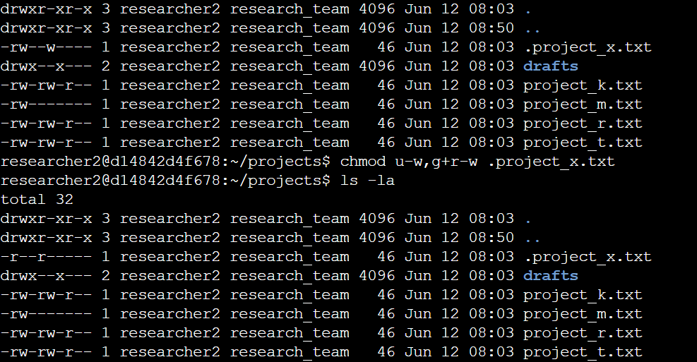

Command used: chmod u-w,g+r-w .project_x.txt

## Change directory permissions

Lastly we removed the execute permission for the group from the drafts directory.

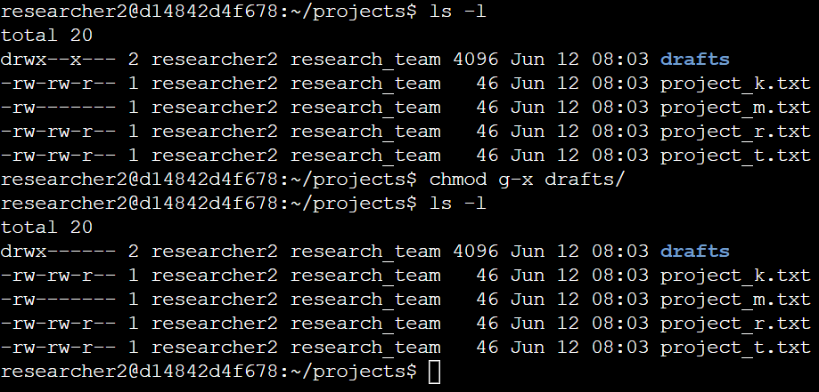

To change the permissions we used command: chmod g-x drafts/

## Summary

Few files were not having appropriate permissions, one hidden file was having more than required permissions and lastly the directory was also having few extra permissions in different owner types. Our team changed the permissions that were needed to be in the right place.